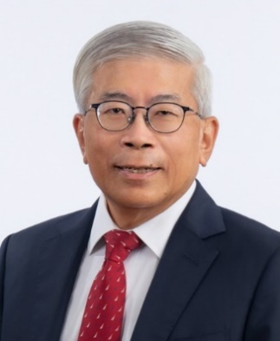

**MR GAN SEOW KEE**

Mr Gan is the Chairman of Singapore LNG Corporation Pte Ltd. Prior to this he was Vice-Chairman and Honorary Treasurer of the Singapore Business Federation (SBF) as well as Chairman of GlobalConnect@SBF. He currently serves on the Council of Presidential Advisers, and co-chairs the Council for Board Diversity. He is a board member of SG Enable, the focal agency for disability and inclusion in Singapore, after co-chairing the Singapore Enabling Master Plan 2030. He is also a member of the Advisory Council of Deloitte South East Asia.

Mr Gan has served on numerous boards and councils in the private and public sectors. He was formerly Chairman and Managing Director of ExxonMobil Asia Pacific Pte. Ltd. He was also President and Director of ExxonMobil China Petroleum and Petrochemical Company Ltd., and served as Board Director in ExxonMobil’s joint ventures in China.

He was conferred the Singapore Public Service Medal (PBM) in 2023, the Distinguished Engineering Alumni Award by the National University of Singapore in 2018 and the Medal of Commendation (Gold) by the National Trades Union Congress in 2017.

Mr Gan obtained his bachelor’s degree in engineering (with honours) from the National University of Singapore and is a Fellow with the United Kingdom Chartered Institute of Management Accountants. He is also a Fellow with the Academy of Engineering, Singapore.