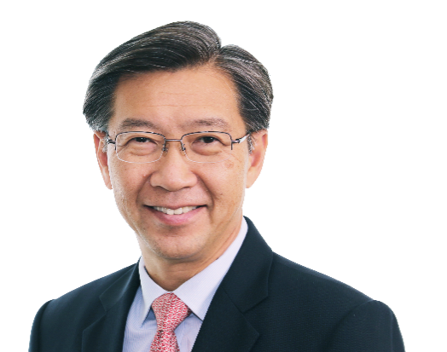

Mr TAN Chong Meng

Deputy Chairman, Temasek Holdings
Chairman, National University Health System (NUHS)

Mr Tan Chong Meng was the Group CEO of PSA International (PSA) until his retirement in March 2024. He joined PSA on 1 October 2011, bringing a wealth of experience in managing the complexity, diversity and breadth of a global business. PSA is a leading global port group and trusted partner to cargo stakeholders around the world.

Mr Tan is currently the Chairman of National University Health System (NUHS), Deputy Chairman of Temasek Holdings, a Board Director of MOH Holdings (MOHH), Temasek Capital (China) Holdings and a member of the National University of Singapore (NUS) Board of Trustees. Mr Tan is also a member of the Council of Presidential Advisers (CPA) since June 2024. Between 2022 and 2024, he served as the Governor Chair for The World Economic Forum’s Supply Chain & Transport Industry Community. He also served as Co-Chairman of the Emerging Stronger Task Force in 2020-2021, a committee set up by the Singapore government to guide the nation’s economic recovery from the COVID-19 pandemic. He was previously a Board Member of IE Singapore.

In May 2023, Mr Tan received two awards: the honour of the Officer of the Order of the Star of Italy — one of the country’s highest civil honours recognising individuals who made outstanding contributions to promote friendly relations and cooperation between Italy and other countries; and the Singapore’s National Trades Union Congress Medal of Commendation (Gold) award for his continuous and significant contributions towards promoting and supporting Labour Movement initiatives. He was also awarded the Meritorious Service Medal in December 2022 for his various roles in the nation’s fight against COVID19. To recognize his contributions to Singapore’s maritime economy, industrial development and healthcare system, Mr Tan has been awarded the Meritorious Service Medal in 2025.

Before joining PSA, Mr Tan was Executive Vice President, Global Commercial, Shell Downstream of the Royal Dutch Shell Group. A global leader with more than 20 years of experience in Shell, Mr Tan worked in USA, Europe, China and Singapore, holding various senior leadership positions that spanned management, sales, marketing, trading, refinery operations, customer service and merger & acquisitions. Mr Tan had also worked with the Ministry of National Development, Singapore in various positions for five years.

Mr Tan received a graduate degree in Industrial Engineering and an undergraduate degree in Mechanical Engineering from National University of Singapore.

