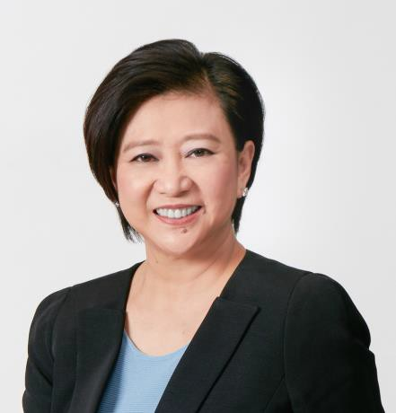

Ms Chua Sock Koong

Ms Chua Sock Koong is Senior Advisor at Singapore Telecommunications Limited, Asia’s leading communications technology group, having served as its Group Chief Executive Officer for 13 years until 31 December 2020.

Sock Koong sits on the Boards of Bharti Airtel Limited, Bharti Telecom Limited, Prudential plc, Ayala Corporation and the Dubai Financial Services Authority, as well as the Supervisory Board of Royal Philips.

She is Deputy Chairman of the Public Service Commission and a member of the Council of Presidential Advisers and the Securities Industry Council.

Sock Koong was conferred the Medal of Commendation (Gold) at NTUC May Day Awards 2016 and the Public Service Star (BBM) at Singapore’s 2019 National Day Awards.

Sock Koong holds a Bachelor of Accountancy (First Class Honours) from the University of Singapore. She is a Fellow Member of the Institute of Singapore Chartered Accountants and a CFA charterholder.

